JAMES COOK UNIVERSITY

SCHOOL OF ENGINEERING

EG4011/2

MY VERY OWN THESIS

Ashley Gillman

Thesis submitted to the School of Engineering in partial fulfilment of the requirements for the degree of
Bachelor of Engineering with Honours
(Electrical)

October, 20th 2014

Statement of Access
I, the undersigned, the author of this thesis, understand that James Cook University will make it available for use within the University Library and, by microfilm or other means, allow access to users in other approved libraries. All users consulting with this thesis will have to sign the following statement:
In consulting this thesis I agree not to copy or closely paraphrase it in whole or in part without written consent of the author; and to make proper public written acknowledgement for any assistance which I have obtained from it.
Beyond this, I do not wish to place any restriction on access to this thesis.

Ashley Gillman Date
Sources Declaration
I declare that this thesis is my own work and has not been submitted in any form for another degree or diploma at any university or other institution of tertiary education. Information derived from the published or unpublished work of others has been acknowledge in the text and a list of references is given.

Ashley Gillman Date

Abstract
Respect the purpose of the abstract, and keep it succinct.

Acknowledgements

Table of Contents
Chapter 1: Introduction 1
1.1 Level 2 heading 1
1.1.1. This is the next level heading 1
And this is the lowest level heading (Heading 4) 1
Chapter 2: Literature Review 2
2.1 White Noise 2
2.2 Speech-Shaped Noise 2
2.3 Babble Noise 2
References 3
Appendix A: Raw Data 4
A-1: Experiment 1 4

List of Figures

List of Tables

List of Symbols

List of Abbreviations
SNR | Signal-to-Noise Ratio
SSN | Speech-Shaped Noise

Introduction
A long time ago …

Level 2 heading
The following paragraph will automatically be in the normal style, which is 11point Times New Roman, with 1.5 line spacing. Do not use carriage returns until you reach the end of a paragraph. Then Word will automatically insert the correct spacing between paragraphs.
See, there is a bit more space. Note also that the paragraph commences at the left hand margin (which is 40mm) – there is no indent.

This is the next level heading
You could type something interesting here.

And this is the lowest level heading (Heading 4)
Unless you want to define more, but this should handle everything that you need … This level will not appear in the table of contents.

Literature Review
Start talking…

Speech Signals

Speech-Shaped, Babble and Competing Speaker Noise
Speech-shaped noise (SSN), also known as large-crowd noise, is noise produced where many speakers are present in the vicinity. It is defined by Krishnamurthy and Hansen [1] as “a diffused background rumble, where individual conversations or speakers are not distinguishable.” They found that this condition occurred with as few as four simultaneous speakers, but in general for seven or more. SSN is a steady-state type of noise, meaning it does not vary in the time domain [2].
Babble noise, also known as the cocktail party effect, is the noise produced by a number of other speakers in the vicinity [3]. Babble noise is defined by Krishnamurthy et al. as the condition where “individual speakers can be heard and at times, individual words can also be heard.” It was found that this condition occurred for between three and six speakers. [1]. Babble noise is often considered the most difficult noise condition for speech processing due to the fact it is very similar in structure to the desired clean signal, and due to the time-variant structure (unlike SSN) [1].
Figure 1 below shows test results by Krishnamurthy and Hansen [1], illustrating the subjective nature of classification of noise as wither babble or speech-shaped (large crowd).
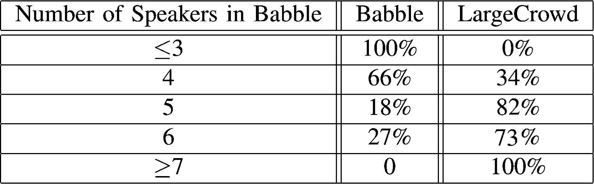
Figure 1 - Subjective classification of babble noise vs. SSN [1]
Competing speaker noise can be considered a special case of babble where there are only two speakers, the target and the masker [1, 2]. Both babble and competing speaker noise are examples of modulated noise, as they do vary in the time domain [2].
Human listeners compensate for babble and competing speaker noise by exploiting the time-modulated property of the noise. Listeners can focus on the target speech during moments of low noise levels to piece together the target’s message. Therefore, human recognition in modulated noise is better than in steady-state noise. However, steady state noise is easier to account for in signal processing than modulated noise [2].

Modelling Babble
It is generally desirable in testing to be able to present noise at different SNRs. Rather than recording noise in a range of conditions directly; it is more convenient to have separate speech and noise and to model the speech with noise signal. Thus, the effects of babble are often modelled rather than directly recorded. This type of babble can be classed as synthetic babble, and may or may not accurately represent real babble [1].
The most common method of creating synthetic babble is to use a number of speech recordings, add them together to form babble [refs]. This presents a number of issues. Firstly, real conversations are not simply a number of voices speaking simultaneously, rather conversations are dynamic, where there is generally one speaker but occasionally more or none [1]. Secondly, this does not take into effect environmental effects, such as reverb, generally present alongside babble [1].
It would be advantageous if babble were modelled in such a way that a signal may be factorized into a noise signal and a clean speech signal. This can be achieved using the non-negative matrix factorisation (NMF) technique [4]. NMF is a technique of approximately factorising a non-negative matrix into two non-negative matrix factors of the form
References
[1] N. Krishnamurthy and J. H. Hansen, "Babble noise: modeling, analysis, and applications," Audio, Speech, and Language Processing, IEEE Transactions on, vol. 17, pp. 1394-1407, 2009.
[2] P. C. Loizou, "Noise Compenation by Human Listeners," in Speech Enhancement: Theory and Practice, Second Edition, ed: Taylor & Francis, 2013.
[3] I. Pollack and J. M. Pickett, "Stereophonic Listening and Speech Intelligibility against Voice Babble," The Journal of the Acoustical Society of America, vol. 30, pp. 131-133, 1958.
[4] N. Mohammadiha and A. Leijon, "Nonnegative HMM for babble noise derived from speech HMM: Application to speech enhancement," 2013.

Raw Data
This is where you put the stuff that people might want to refer to, but isn’t essential to the report.

Experiment 1
There are two levels of subheading for appendices.

